**Damages Claims Frequently Asked Questions (FAQs) document**

***Q:******If we register for the new service, we will still be able to use the old PD51S online system?***

A: The PD51S online service was closed for issuing new cases as of 28th February 2022.

***Q: If you are already registered with the service is it necessary to re-register?***

A: No, it is not necessary to re-register.

***Q: I am trying to log into the portal but the screen is constantly refreshing, how do I fix this?***

A: This may be an issue with the URL. Ensure that any saved bookmarks read as <https://manage-org.platform.hmcts.net/> or [https://manage-case.platform.hmcts.net/](https://eur01.safelinks.protection.outlook.com/?url=https%3A%2F%2Furl6.mailanyone.net%2Fv1%2F%3Fm%3D1lAWx0-00096W-5b%26i%3D57e1b682%26c%3DS9zslkTAv49EegVhm9ubI1LKpPmQsmDYaBFbQr7p1Hn47t5nyPb-7OG8DO1HAV98ETh1AhPKl5Aru5J-i4WWAYAtwpP9H-cskVGCkpoOODicGX8NYjz9CrBHkyT1fljWhff44sIKLB4B5ybHJkkv9x4HfDkBSH958OH0bkVW6Sotkhw8PN-XdoX7ctTEByoETk34KwZTmJU5oJWhQ1KmVSqfpMkXiMuUvGccpjcH9nmPn3-xnkBiFkqyda1N9EP6&data=04%7C01%7CMBelcher%40truemans.org.uk%7C115dd242461d4a95ff6b08d8d81bf153%7Ca408314de54749339ebf6e81648ebc48%7C0%7C0%7C637496961829294176%7CUnknown%7CTWFpbGZsb3d8eyJWIjoiMC4wLjAwMDAiLCJQIjoiV2luMzIiLCJBTiI6Ik1haWwiLCJXVCI6Mn0%3D%7C1000&sdata=tQbbWrN%2BmAbDL5SPZV71A%2Fn3YEdyI2DNmyVRkfRhgHs%3D&reserved=0). If the URL displays any differently, then this causes the screen to constantly refresh. If the problem persists, please contact [MyHMCTSsupport@justice.gov.uk](mailto:MyHMCTSsupport@justice.gov.uk) for further assistance.

***Q: What have volumes been like within the DCP to date? Are more law firms due to sign up in the near future?***

A: As of the week ending the 8th May 2022, there had been a total of 9002 claims issued via the DCP. All claims that are covered by PD51ZB should now be issued via the portal & this service is available for all users.

***Q: Will there be limited defendant organisations on the system?***

A: Defendant organisations will need to be registered for My HMCTS. You can search for the solicitor details using the service and if they are a registered user, their details will appear. Once you have created the claim and triggered the notification of claim the defendant solicitor will receive an e-mail notifying them of the claim.

Currently, the claimant solicitor is required to contact the defendant legal representative in order to ascertain whether they are currently accepting service of claims via the DCP before issuing the claim. Whilst a firm may be registered with MyHMCTS, this does not automatically mean that they are accepting service. This practice should be followed until it is mandatory for the defendant solicitors to use the portal.

***Q: Is only one registration needed for a firm that does both claimant and defendant work? Can users then be added as required?***

A: You only need to register once in MyHMCTS, you are given different roles within the system, e.g. if you issue a claim the system recognises you are the claimant, if you respond the system recognises you are the defendant.

***Q: Can I just check that the process is that each solicitors practice has an MyHMCTS account and that we then allocate users under that account, or does this system require a separate account?***

A: Each Solicitors practice is required to register with MyHMCTS, on registration the person who registers becomes the Case Administrator and can then add users.

***Q: How many users can each claimant firm have in the online system?***

A: With the new service, once your organisation is registered on MyHMCTS then you have control on how many users you want to have access in your organisation. There is no limit on the number of users.

***Q: Is the DCP just for use by solicitors at present? If so when will it be opened up for insurers/insureds to register for use?***

A: The DCP is at present only for parties that are legally represented. The pre action journey is not to be reviewed at this present time, however, it is an area that will be considered moving forward in the digital journey.

***Q: Is a PBA account number autosaved?***

A: Yes, when registering for My HMCTS you will be asked to input the firm’s PBA account number(s). If this step is completed correctly when issuing a claim, the firms PBA account numbers will appear.

***Q: Is there a Manager/Supervisor tool to check cases to ensure nothing is missed?***

A: Within MyHMCTS platform there is the function for different user types, superusers and case administrators. The superuser is the person within your organisation who can add accounts. The Case Administrator will see the case appear in the unassigned cases list and an emailed notification will be received by the nominated email address. If all claims are to be viewed by one person within the organisation, then all the claims will need to be shared.

***Q: Do you receive an acknowledgement email when you complete each task to be retained in your own case management system?***

A: Yes.

***Q: Can we setup a central email address for notifications?***

A*:* All notifications will go direct to the assigned solicitor. We have not opted to send to a central e-mail box as some of the notifications carry a lot of importance, e.g. notifying the defendant solicitor of the claim details. If the notification went to a central e-mail there is a risk, if e-mails are not monitored, that it could be missed and therefore could have consequences on the defendant. It is therefore important to send to a named person to ensure deadlines are not missed. If a firm wishes to allocate a generic email inbox for claim issue this is acceptable.

There is now an active functionality to change an email address once the case is assigned so that all notifications are received by that user rather than a generic email address.

The email notification will only be sent to the email address registered on the claim. If the main litigator is away from the office and cover is required. All claims must be shared with another and that person will need to change the email address on each case in which they wish to receive the email notifications.

***Q: Once a case is assigned to a specific user, do updates continue via email to the assigned handler?***

A: All future notifications will be issued to the email address noted on the claim.

***Q: If notifications go to my e-mail address, what happens during leave periods?***

A: There is a function within My HMCTS to share a case with a colleague which provides access to the case to enable cases to be covered/managed on your behalf during leave periods. As soon as a case becomes assigned to your firm, it is recommended that it is shared to another user to account for unforeseen absences.

If another needs to receive the email notifications once the main file handler is away from the office, then they need to update the email address noted on the case.

***Q: Will the Defendant CAA user receive an email to say a claim has been issued, then the superuser knows to check the portal and allocate to a solicitor?***

A: Once a claim has been issued, we ask the claimant to provide an e-mail address for the Defendant solicitor. The Defendant solicitor will receive an e-mail to notify the claim has been issued. The CAA user can then go into the unassigned cases in the MyHMCTS portal and assign to a solicitor.

***Q: Will it be possible to identify the case in the system by case name when searching rather than court case number?***

A: There is no functionality to search by name, however, there is the facility to search by both CCD Reference Number and Caseman Reference Number.

***Q:******What file types are supported by the system? e.g. PDF, Excel etc***

A: The system will cover most files types, e.g. PDF, Word, Excel, txt format and rich text format. Given that any file type can be saved as a pdf, if a solicitor is using a file type that is not supported by the system then the answer is to save the file as a PDF and then upload the PDF.

***Q: Can you download documents in bulk or is it on a case by case basis by the specified case handler?***

A: Documents will need to be downloaded in a case by case basis. We can explore bulk download with our tech team for future releases.

***Q: With the aim of the wider civil justice service becoming more digitalised and the operation of other existing claims portals such as the OIC portal and the original MoJ Portal in mind – has any thought been given to the Damages Claims Portal being opened up to cover other types of claims – perhaps those small claims in the current Money Claims Online service?***

A: The aim is to eventually have all civil claims issued via one joint portal. However, currently the DCP does not cover PD7E and PD27B.

***Q:******With the long-term intention for the DCP to be a complete end-to-end portal from pre-litigation to enforcement – when might we expect it to be extended to cover the pre-litigation stages of a claim?***

A: The pre litigation element of a claim will be a consideration when the digital service is working from claim issue to final hearing

***Q: Is there an API available? And if not will it be available in the future?***

A: API is not in scope at present, however, we have received consistent feedback and we have an understanding why this is important, therefore we are committed to implementing.

***Q:******We understand a recording of the pre-launch webinar will be available so we can make it available to other members who haven't been able to join today?***

A: A webinar video demonstrating the portal use is available to view on the HMCTS YouTube channel & can be found here <https://www.youtube.com/watch?v=gVIhyYlggCg>

Please direct any further questions to our e-mail address [damagesclaims@justice.gov.uk](mailto:damagesclaims@justice.gov.uk)

***Q: Where do we get support for the product? Is there a central helpdesk to assist users if there is something which goes wrong on the portal?***

A: There is support available for the service, there is a dedicated Call Centre No: 0300 1231372 and a dedicated Tech Support who deal with live issues E-mail : [damagesclaims@justice.gov.uk](mailto:damagesclaims@justice.gov.uk) or [MyHMCTSsupport@justice.gov.uk](mailto:MyHMCTSsupport@justice.gov.uk)

***Q: The DCP is currently only available for use in single party cases. When will the portal be extended for use in claims where there are multiple parties?***

A: The Multi Party (1v2 and 2v1) enhancement went live as of the 28th January 2022, which will allow firms to use the Damages service for 97% of their claims.

***Q: Does this service cover clinical negligence claims?***

A: Yes, one of the case categories is clinical negligence. It is intended to cover all Damages claims in the County Court which can be brought under Part 7. The limitations are parties involved. These can be 1v1, 2v1 or 1v2.

***Q: Is the system also suitable for non-personal injury cases – i.e. damage only RTAs?***

A: Any damages claims, not just personal injury, however, there are a number of exclusions. We have an eligibility screen which details exactly what is included. Please see attached at Annex A.

***Q: Does this system apply to Part 8 Claims/stage 3 MOJ portal claims?***

A: The scope of the portal only applies to claims brought under Part 7 at the moment and does not apply to Part 8 claims.

***Q: Is there any limitations upon using this with reference to any potential value of the claim (MT/High Court etc.)?***

A: No limitations in terms of value of the claim as long as the claim meets the eligibility criteria.

***Q: Will litigants in person be able to use the DCP in the future?***

A: Yes

***Q: When starting a case and to issue, should we always select CCMCC like we issue paper proceedings, or can we select the suitable county court?***

A: When issuing through the portal you should select the preferred Court you would like any future hearings to be heard. There is a web link to the court finder if you are unsure of the Court’s details.

***Q: If a defendant firm is not registered and the claimant tries to issue via the portal, and it drops out, is the Defendant then notified in the usual way (i.e. the responsibility of the Claimant to serve by email)?***

A: Yes, when the case drops out into the mainstream CPR rules the claimant is expected to follow the existing rules. Once the claim drops out of the portal it is treated as if it had been issued under CPR 7.

***Q: If the Defendant doesn't agree to use the portal, are you still able to issue the claim form through the portal for manual service?***

A: Yes, you can still issue the claim via the portal and it will show as Claim Proceeds Offline.

***Q: I have reached the ‘check your answers’ page & have pressed the submit button to issue the claim but the portal has frozen. What shall I do?***

A: If this occurs, close down the portal using the X at the top right of the screen. Log back into the portal & you should find that the claim has in fact been issued. If not, you will be required to complete the issue stage again. Please **DO NOT** use the ‘back’ button on your web browser & select submit again. This could cause the claim to be duplicated & issued twice as well as taking a second fee from your firm’s PBA account.

***Q: I have submitted my claim, but it is currently in ‘Claim Issue Pending’ state. What do I do?***

A: **If a claim is appearing in claim issue pending state, this means the claim is not yet issued and therefore will not cover limitation**. Check that your firm’s PBA account has sufficient funds available to cover the issue fee. Log back into the claim & select the ‘Resubmit Claim’ action from the next steps drop down box to see if this successfully issues the claim. If this does not resolve the matter or you receive a ‘callback’ error message, then please contact the damages team on [DamagesClaims@justice.gov.uk](mailto:DamagesClaims@justice.gov.uk)

***Q: What is the process when a claim is being dealt with by a claimant solicitor and an insurer when it comes to issuing proceedings within the DCP? What steps does an insurer need to take to transfer the claim to a panel solicitor (who they may have had no interaction with at that time) – in order to keep the claim within the DCP? Is there additional information the insurer would need to send to the Claimant’s solicitor/their panel solicitor?***

A: As pre action steps are not yet being considered within the DCP, this may be something best discussed between insurer firm and panel solicitor firm. If there is an agreement in place with the panel firm that they are willing to accept any damages claim via the DCP this would allow the insurer firm to confirm this with the claimant firm.

***Q: What happens if you need to transfer a case from the CC to HC or RCJ? Does it 'drop out' of the portal and you proceed in accordance with CPR Part 30?***

A: You can apply at any stage for the case to come out of the system, in general terms, it will then carry on as if it had been issued under Part 7 and listed for directions in the County Court, or you can apply to transfer to the High Court and it will come out and transferred to the High Court. The first release is quite limited, and it will automatically come out of the system following the DQs and carry on as if it had been issued under Part 7. As we release further functionality, you will be able to stay within the portal for longer. Although it should be emphasised either party can at any stage apply for the case to come out the system or the Court can apply for the case to come out of the system.

***Q: Would I be right to assume that a Part 20 Counterclaim will take it out of the system??***

A: Yes, at this stage in the digital journey, counter claims would have to proceed out of the system.

***Q: Not proceeding with the claim: Is that just a temporary pause in the process or a discontinuance?***

A: If the Claimant solicitor completes the intention to proceed step by selecting ‘no’ then the claim is discontinued.

***Q: Is there an obligation under the portal to serve a claim protectively at the end of the 4 month period?***

A: It is necessary for the claim to be served within 4 months of issue. Otherwise, it will be automatically struck out. If an extension of time is required, then it will be necessary to make a paper application to CCMCC at Salford. When that application is processed the case will come out of the portal and will be treated as if it had been started under CPR 7, so the claim form will not be valid after 4 months unless an extension of time is granted.

***Q: Can you download the claim form after it's been submitted and what does it look like?***

A: Yes, the sealed claim document is available to download, this can be found in the Claim Document tab. An example claim form taken from a test case is attached here. 

***Q: Is there a facility for the info to be checked by a senior member of the team before it is submitted? Can anyone access the info before submission?***

A: There is no functionality built in for claims to be checked by another user before issuing, however there is a Check Your Answers page before you submit the claim in which all information entered can be double checked & edited before submission.

***Q:*** ***Can you amend the claim form before service on the system?***

A: Once the claim has been issued, you cannot amend details on the claim form within the portal system. If you want to amend you would have to send an amended claim form to CCMCC. Following this release, we are focusing on expanding the system to include enhancements as well as general applications.

***Q:* *If you amended the claim form offline would it be possible to then upload the amended claim form to serve with the POC or would you need to serve "the old fashioned way"?***

A: As soon as you take any action offline, the case leaves the digital journey, unfortunately you would need to serve the normal way.

***Q: Can you save part way through and come back to complete at a later date/time?***

A:No, there is not a pause function in the service.

***Q: When a claim has been assigned to a litigator will the email address for the future email notifications be updated?***

A: No, if an email address needs to be amended for another person to receive the email notifications then this must be done through the change email address option in the next steps drop down list.

***Q: I have completed the acknowledgement of service step, but the option is still appearing in the next steps drop down list, is this correct?***

A: This is correct, if you were to try and repeat the completed step then you would receive an error message.

***Q: When I’ve created my claim online, do I still have to serve hard copies on the defendant & send copies of case documents to the CCMCC?***

A: All the time that the case remains on the DCP, you are not required to duplicate the service of documents to either the defendant or the CCMCC. Once a claim reaches the ‘Case Proceeds Offline’ stage, all dealings from that point onwards will follow the normal paper journey.

**Q: *After the defendant gives notification of the defence are there time limits for the claimant to complete the DQ?***

A: Once the defendant has responded to the claim, then intimated they wish to defend the case and uploaded the defence, there are time limits for the claimant to complete their part of the Direction Questionnaire. The time limit depends on the provisional allocation of the case to a track of 14 days or 28 days. This mirrors the existing CPR 26.3 procedure rules. Failing to complete on time would result in the case leaving the digital journey.

***Q: Can you assess the Defendant's DQ before completing your own?***

A: When a ‘next step’ action is completed in the portal the history tab will be updated with the ‘next step’ title and information provided in that step can be viewed when clicking the event title. You can also view PDF version of the document in the Claim documents tab.

***Q: What happens if you only want to acknowledge service initially within the 14 day period to do so and then file Defence later - it looked like you had to upload the Defence at the same time as acknowledging service …..?***

A: The usual CPR time scale are reflected in the portal. Meaning a defence is required within 28 days from being notified of the claim details.

***Q: Can you part complete a DQ and come back to finish later*?**

A: Yes, there is the facility to do this.

***Q: Can extensions for submitting a response be added to the system?***

A: There is scope within the system for parties to agree an extension of time. That agreement will be made offline between the parties themselves, e.g. via email. The system can then be updated with the agreed extension.

***Q:******Can you file further pleadings e.g. a Reply or a Part 18 Request?***

A: Not at this time.

***Q: Will we be able to file cost budgets at the same time as Direction Questionnaire (DQs)?***

A: In the new practice direction there is a slight change to how a cost budget is filed. You are not expected to file with DQs. Once DQ information has been agreed by both parties, the case is transferred to the local court. If the case is allocated to the Multi Track, directions will be provided by the District Judge on when those cost budgets need to be filed at court.

***Q: Can fee remission applications be submitted using the new service? Is this possible even if the documents have been completed by hand (i.e. are not necessarily machine readable)?***

A: An application for Help with Fees can not be submitted at this stage when issuing a claim. A retrospective Help with Fees refund application can be made up to 3 months once the fee has been paid which would be submitted to CCMCC. There are plans in the future to enhance the service to allow Help with Fees applications at the issuing stage.

**Annex A – Claim Eligibility**

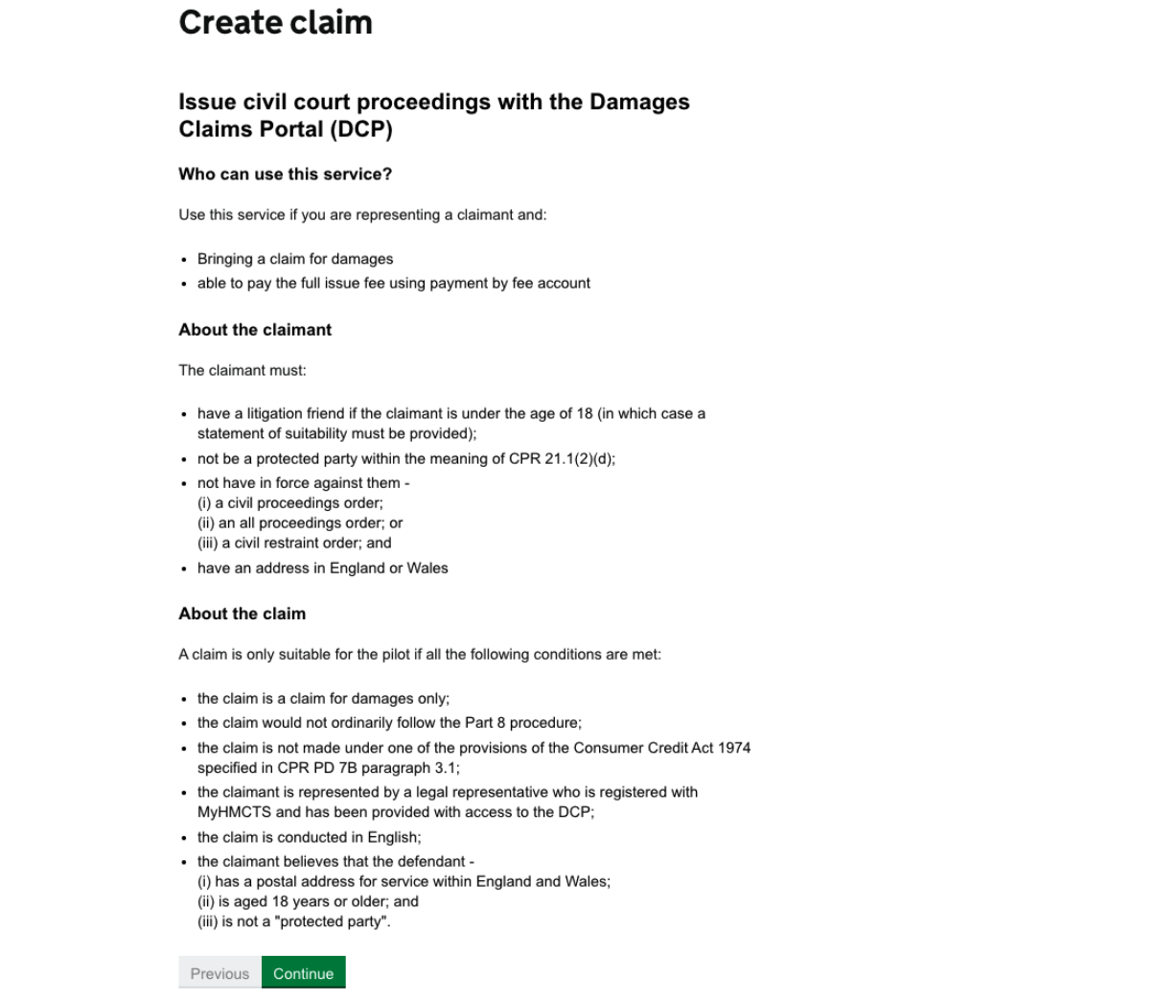

The Damages portal is purely for County Court unspecified claims including: -

* Personal Injury
* Road Accident
* Work Accident
* Public Liability Accident
* Holiday Illness
* Disease Claim
* Clinical Negligence
* Professional Negligence
* Breach of Contract
* Consumer Credit (Not PPI)

Claims falling under PD7E or PD27B remain unaffected by the Damages Portal & should be issued in the normal way via the CCMCC.

Do you have any Top Tips? Please let us know by

e-mailing [damagesclaims@justice.gov.uk](mailto:damagesclaims@justice.gov.uk)

If you are experiencing any issues, there is support available please contact the dedicated

Call Centre No: **0300 1231372** or

Email for issues with the portal: [damagesclaims@justice.gov.uk](mailto:damagesclaims@justice.gov.uk)

Email for issues with registering or your MyHMCTS account: [MyHMCTSsupport@justice.gov.uk](mailto:MyHMCTSsupport@justice.gov.uk)

Email for case specific queries with the CCMCC: [ccmcccustomerenquiries@justice.gov.uk](mailto:ccmcccustomerenquiries@justice.gov.uk)

Email for filing of case specific documents: [ccmcce-filing@justice.gov.uk](mailto:ccmcce-filing@justice.gov.uk)