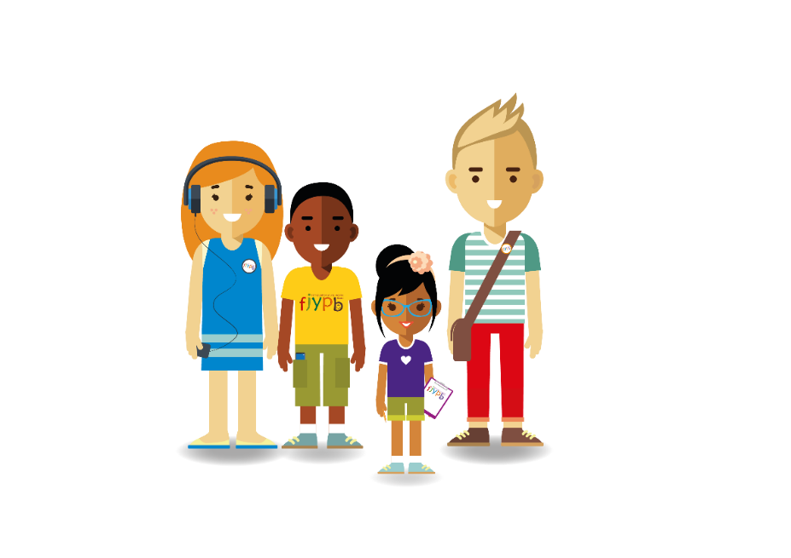

**The FJYPB members are children and young people with experience of family law proceedings. They have devised these top tips for parents to help them think about matters from their child’s perspective.**

**‘LISTEN TO YOUR CHILD’**

**You can find out more about the FJYPB at Cafcass.gov.uk**